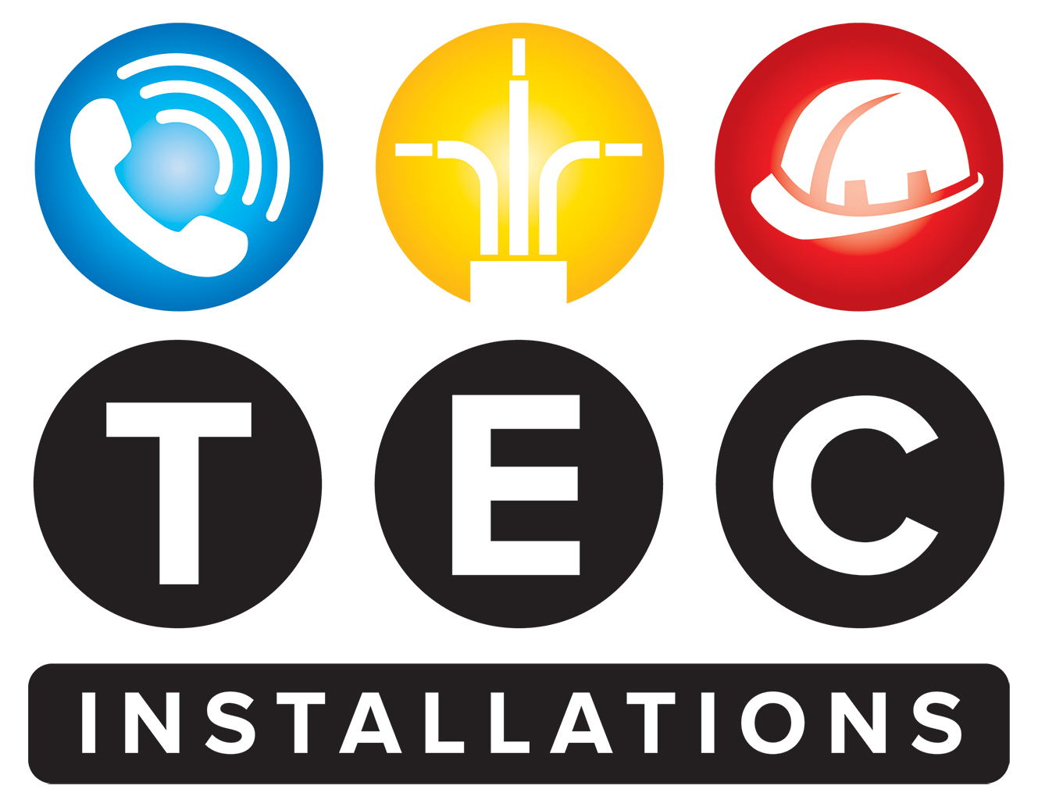

**Corporate Social Responsibility (CSR) Policy**

**TEC Installations LTD**

**Effective Date:** 01/06/2025  
**Review Date:** Annually

* **1. Introduction**

TEC Installations LTD is dedicated to operating in a socially responsible, ethical, and sustainable manner. This policy affirms our commitment to positively impacting our community, environment, and stakeholders while maintaining compliance with UK laws and regulations.

* **2. Purpose**

The purpose of this policy is to define our approach to corporate social responsibility, ensuring responsible business practices across all aspects of our operations.

* **3. Scope**

This policy applies to all employees, contractors, suppliers, and representatives of TEC Installations LTD working within the UK.

* **4. Our Commitments**
* **4.1 Ethical Business Practices**
* Conduct all business activities with honesty, transparency, and integrity.
* Comply with all applicable UK laws, including anti-bribery, anti-corruption, and fair trading regulations.
* Uphold the highest standards of corporate conduct and accountability.
* **4.2 Environmental Responsibility**
* Minimize the environmental impact of our operations through responsible resource use, waste reduction, and pollution control.
* Promote energy efficiency and sustainable practices in procurement, operations, and transportation.
* Support initiatives that help preserve local biodiversity and natural resources.
* **4.3 Community Engagement and Support**
* Actively engage with and support local communities where we operate through volunteering, sponsorship, and charitable activities.
* Encourage employee participation in community service and development initiatives.
* Foster strong, mutually beneficial relationships with local stakeholders.
* **4.4 Employee Welfare, Diversity, and Inclusion**
* Provide a safe, healthy, and respectful workplace environment.
* Promote diversity, equality of opportunity, and inclusion across all levels of the organization.
* Invest in employee development through training, mentoring, and career progression programs.
* **4.5 Responsible Supply Chain Management**
* Ensure our suppliers adhere to ethical standards, including fair labor practices, health and safety, and environmental stewardship.
* Conduct due diligence and audits to verify supplier compliance with our CSR standards.
* Collaborate with suppliers to improve sustainability and social responsibility.
* **4.6 Stakeholder Engagement & Transparency**
* Maintain open and honest communication with all stakeholders, including customers, employees, suppliers, and communities.
* Regularly report on our CSR performance, goals, and initiatives to ensure transparency and accountability.
* **5. Implementation and Monitoring**
* The senior management team is responsible for embedding CSR principles into our corporate culture and operations.
* Managers and team leaders are tasked with implementing specific CSR activities within their areas.
* CSR performance will be reviewed annually, with progress reported to the Board.
* Continuous improvement will be driven by stakeholder feedback, legislative changes, and best practices.
* **6. Commitment to Legal Compliance and Ethical Standards**

TEC Installations LTD is committed to complying with all relevant UK legislation, including the Companies Act 2006, the Modern Slavery Act 2015, and environmental legislation, ensuring that responsible business practices underpin our operations.

* **7. Review and Updates**

This policy will be reviewed annually or following significant organizational or legislative changes to ensure ongoing relevance and effectiveness.

**Approved by:**  
Dale Carroll

Managing Director

01/06/2025