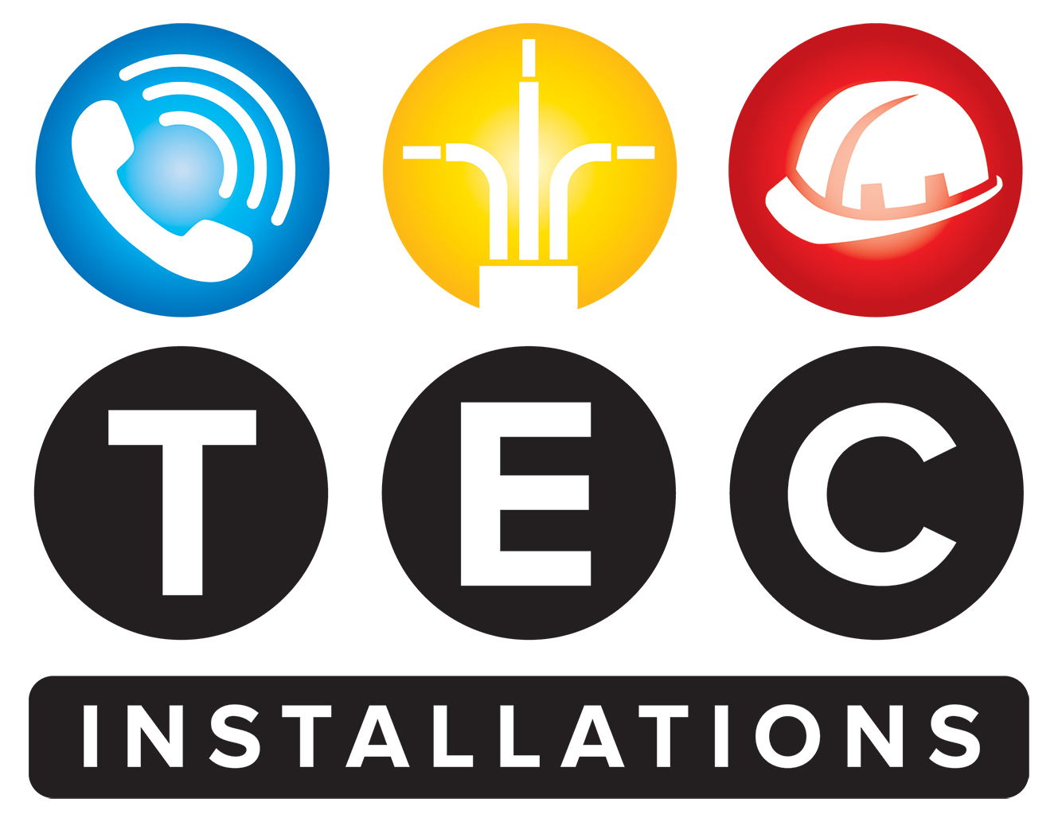

**Quality Management, Supplier Assurance, and Continuous Improvement Policy**

**TEC Installations LTD**

**Effective Date:** 01/06/2024  
**Review Date:** Annually or as required

* **1. Purpose**

TEC Installations LTD is committed to providing high-quality services and products that meet or exceed customer requirements and industry standards. This policy defines our arrangements for managing product specifications, ensuring supplier quality, and continuously improving our quality performance.

* **2. Scope**

This policy applies to all staff, contractors, suppliers, and processes involved in the specification, procurement, delivery, and review of quality within TEC Installations LTD’s operations.

* **3. Supplier Assurance and Quality Management**
* All suppliers must apply appropriate quality management measures relevant to the scope of work they provide.
* We evaluate and select suppliers based on their quality standards, compliance with legal and regulatory requirements, and demonstrated ability to meet our quality expectations.
* Contracts explicitly specify the quality expectations, including adherence to recognized standards such as ISO 9001 or equivalent.
* Ongoing monitoring, audits, and performance reviews are conducted to ensure suppliers maintain acceptable quality management practices and contribute to continuous improvement.
* **4. Product Specifications and Standards Integration**
* All products specified and used in our projects reference relevant classification standards as part of a subsystem approach, ensuring compatibility and compliance.
* Specifications include explicit references to applicable standards.
* Product classifications are considered within the full system context to promote safety, functionality, and regulatory compliance.
* Verification procedures ensure that specified products align with the designated standards and system requirements.
* **5. Risk Management**
* TEC Installations LTD maintains robust risk management policies, procedures, and systems to identify, assess, and mitigate potential risks across all projects.
* Risk assessments are conducted periodically, documented thoroughly, and include control measures to reduce identified risks.
* Risk registers are maintained for all projects, with regular updates and reviews.
* Staff are trained to recognize and manage risks effectively.
* Risks are escalated promptly to senior management for resolution.
* **6. Review, Correct, and Improve Quality Performance**
* We have formal procedures for periodically reviewing our quality performance, including conducting regular audits and reviews of operational processes and outputs.
* Performance data and KPIs related to quality, safety, and efficiency are monitored routinely to identify areas for improvement.
* Corrective and preventive actions are implemented when non-conformances or deficiencies are identified.
* Senior management reviews quality performance reports periodically to identify improvement opportunities and set objectives.
* Feedback from clients, staff, and audits inform our continuous improvement initiatives.
* **7. Responsibilities**
* Senior management ensures overall commitment to quality, supplier assurance, and continuous improvement.
* Department managers and team leaders are responsible for implementing procedures, conducting reviews, and ensuring staff adherence.
* All employees are expected to comply with this policy, participate in training, and contribute to ongoing quality improvement.
* **8. Compliance and Review**

This policy will be reviewed annually or more frequently if necessary to adapt to changes in industry standards, legal requirements, or operational needs. Compliance is mandatory for all staff and contractors.

**Approved by:**  
Dale Carroll  
Managing Director  
01/06/2025